**Colonial Adventure Tours Case Questions**

The management of Colonial Adventure Tours wants you to complete the following exercises.

1. **The DBA asks for your help in planning the data archive (not backup) for the following Colonial Adventure Tours database:**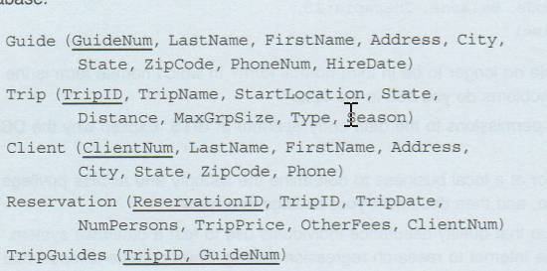

**Determine which data from the database to archive; that is, for each table, specify whether data needs to be archived. If it does, specify which data, when it should be archived, and whether it should be archived with data from another table.**

In order to satisfy all necessary legal requirements, most of the data will need to be archived. However, there may be some data that does not need to be from each table.

* For the Guide entity, all of the data should be kept for accounting purposes. The HireDate field indicates that Colonial Adventure Tours hired all of the tour guides. In order to satisfy any legal accounting standards, and because the company may need to reference this information in the future, all data from this entity should be kept.
* For the Trip table, only the necessary information should be kept. Attributes such as the StartLocation, Distance, and Type are not necessary information and may be removed for archival. The data used for recognition purposes should be kept, such as the TripID, TripName, and State. To help with accounting purposes, the MaxGrpSize and Season attributes should be kept. The archived entity will look as follows:
  + Trip (TripID, TripName, State, MaxGrpSize, Season)
* In order to satisfy all legal requirement relating finances and accounting, all data from the Client entity should be kept. All data from this entity may be used for future reference for accounting purposes or legal audits.
* In order to satisfy all legal requirements relating to finance and accounting, all the data should be kept from the Reservation entity. This table in particular shows all the data relating to the transactions performed by Colonial Adventure Tours.
* In my view, the TripGuides entity does not need be archived. All of the information one could gather from this entity could probably be found through the other entities that were archived. However, if the amount a tour guide is paid from Colonial Adventure is related to the places they are tour guides for, then all the data from this entity should probably be kept.

1. **The DBA denormalized some of the data in the Colonial Adventure Tours database to improve performance, and one of the resulting tables is the following:** 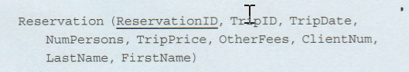

**Which field or fields cause the table no longer to be in third normal form? In which normal form is the denormalized table?**

The fields that cause the table to no longer be in third normal form are the LastName and FirstName attributes. When these attributes are added, ClientNum becomes a determinant, but it is not the candidate key. The denormalized table is in second normal form because it is in first normal form (it does not contain any repeating groups) and “no nonkey column is dependent on only a portion of the primary key” (Starks et al, 2018). However, the table is not in third normal form because it contains a determinant (ClientNum) that is not also the candidate key (Starks et al, 2018).

1. **Interview the DBA at your school or at a local business to determine the safeguards used to segregate the production system from the test system.**

I was unable to interview a DBA. However, I was able to interview my father, Jim McConville, on the subject. McConville is an IT Programming Expert, Data Engineer, and Project Manager at the General Services Administration (GSA) and has done much work on various databases for the organization. Through his work, he has been granted various administrative privileges similar to that of a DBA.

Some of the safeguards used to segregate the production system from the test system on some the databases McConville has worked on include placing the test system and production system on different servers (McConville, 2021). Each server has controls which allows certain users access. Though there are several different controls for each server, there tend to be many more on the production system (McConville, 2021). Those controls on the production system also tend to be more stringent (i.e. the number of users who have access is much more limited). The data contained on the test system differs from that on the production system but is similar enough to retain the same functionality of the production system (McConville, 2021). An example of one change that is made on the test server is any personally identifiable information is removed (McConville, 2021). When changes are made in the test server that need to be implemented in the production system, these changes must also be approved by the acting DBA, as well as other security officials (McConville, 2021).

1. **You are the DBA for Colonial Adventure Tours. The company is considering accepting reservations from sports clubs, such as hiking clubs. The reservation would be for the entire group. What changes to the database structure would you need to make to accommodate accepting reservations from groups or organizations as well as individuals?**

In order to accommodate the accepting of reservations from groups or organizations, as well as individuals, some changes would need to be made to the database structure. There would not have to be made to the Client Table. The club can still have a ClientNum as its primary key. The FirstName and LastName attributes should be based on the leader of the group or club. The Address and other contact information attributes should be that of the group or club. Next a new entity should be made that helps to give information regarding all the groups or clubs Colonial Adventure Tours does business with. The entity could be called something like ClubClients. The entity can have attributes pertaining the group leader’s first and last name called something like LdrFirstNme and LdrLastNme. The entity should also have an attribute that shows the size of the club or group. Lastly, there should be an attribute that shows the name of the club or group. This attribute can be called something like ClubName. The new entity would look as follows:

ClubClients (ClientNum**,** ClubName, ClubSize, LdrLastNme, LdrFirstNme, Address, City, State,

ZipCode, PhoneNum)

References

McConville, J. (2021, April 18). Week 7 Assignment Interview [Telephone interview].

Starks J. L., Pratt P. J., & Last M. Z. (2018). *Concepts of Database Management*. [VitalSource

Bookshelf]. Retrieved from https://online.vitalsource.com/#/books/9780357246856/